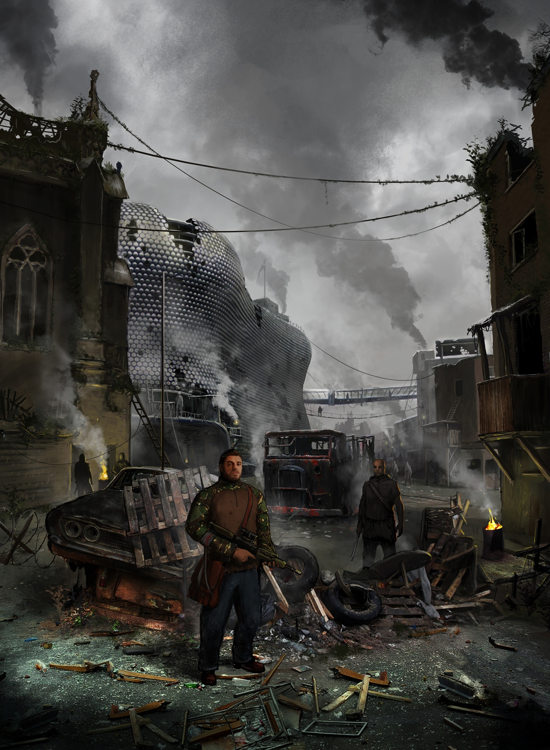

Dreamcatcher

Roleplaying Game

By Barry Dewey -Robertson

V 0.2

What dreams are made of

Cover Illustration Copyright © 2014-2015 5ofnovember

Cover design by Barry Dewey-Robertson

Book design and production by Barry Dewey-Robertson

Editing by Barry Dewey-Robertson

Introduction Chapter opening illustration “The Burning of the Sky 3” © 2014 – 2015 5ofnovember

Chapter 1 opening illustration “Castle ruins” © 2013 – 2015 L Morse

Chapter 2 opening illustration “Marching” © 2014 – 2015 Taaks

Chapter 3 opening illustration “Cityscape Clean Final” © 2014 – 2015 Mitchell Mohrhauser

Chapter 4 opening illustration “Lava landscape” © 2012 – 2015 Jonathan DeVos

Copyright © 2015 by Barry Dewey-Robertson

All rights reserved. No part of this publication may be reproduced, distributed, or transmitted in any form or by any means, including photocopying, recording, or other electronic or mechanical methods, without the prior written permission of the publisher, except in the case of brief quotations embodied in critical reviews and certain other noncommercial uses permitted by copyright law.

This is a work of fiction. Names, characters, businesses, places, events and incidents are either the products of the author’s imagination or used in a fictitious manner. Any resemblance to actual persons, living or dead, or actual events is purely coincidental.

Contents

Introduction 1

Chapter 1: Basic Rules 2

Tests 2

Performing a Test 2

Hampered Abilities and Advantages 3

Degrees of Success 3

Destiny Points 3

Resolving the Test 3

Contests 3

Resolving the Contest 4

Combat 4

Multiple participants and Aiding 4

Narrative Override 5

Chapter 2: Ability Scores 6

Forceful 6

Deft 6

Resilient 7

Intelligent 7

Perceptive 7

Chapter 3: Characters 8

Step1: Character Premise 8

Step 2: Assign Ability Scores 8

Step 3: Create three Advantages 9

Step 4: Create a Relationship 9

Step 5: Create a special Possession 9

Step 6: Create four Hindrances 10

Step 7: Personal Touches 10

Step 8: Play your introduction 10

Step 9: Character Development 10

Chapter 4: Games Mastering 12

Time 12

Distance and Movement 13

Perception 13

Hampering, Injury and Death 13

Healing and Recovery 14

Managing Scenes 14

Managing Test 15

Managing Contests 16

NPCs 16



# Introduction

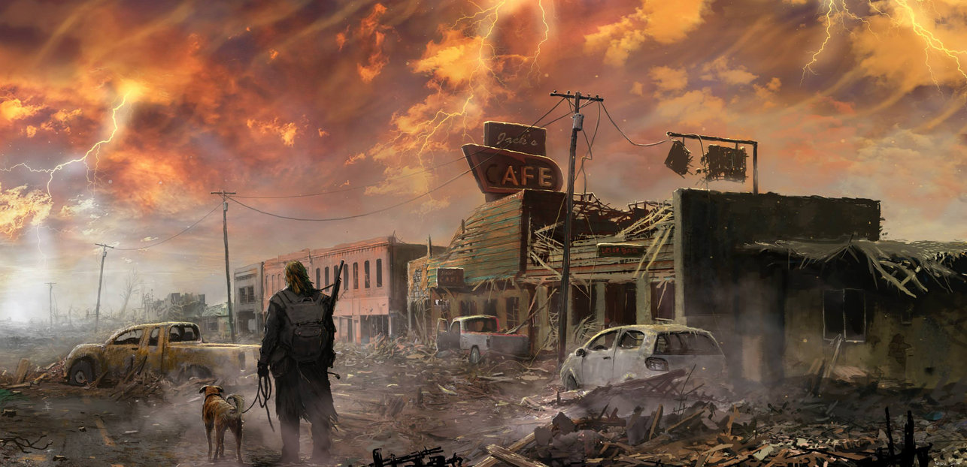

The Dreamcatcher system is intended to be a rules light generic, modular system with a substantial focus on promoting a narrative style over complex rules. These rules are still in the beta stage, and could change substantially based on feedback.

As with all roleplaying games, Dreamcatcher games take place in your mind, using imagination over boards or computer generated characters. The Games Master (GM) describes scenes and actions of other people within the world to you and your fellow players, and using your imagination you respond by asking questions and describing the actions of your characters in turn. If a contest arises, then your character’s abilities and are used to overcome the challenges presented.

“Dreamcatcher games take place in your mind”

These rules assume that players have access to at least two, but ideally three, six sided dice (known in gaming circles as D6), a character sheet, and a pen, pencil or similar implement. If you are the GM you should have your own dice, a copy of the rules, a way to take notes, and either a prewritten adventure, or one of your own making. Some GMs and players like to use miniatures, battle mats, dungeon tiles, scenery and other such visual aids to enhance the experience, and although these can be used with the game, they are not required to play.

# 

# Chapter 1: Basic Rules

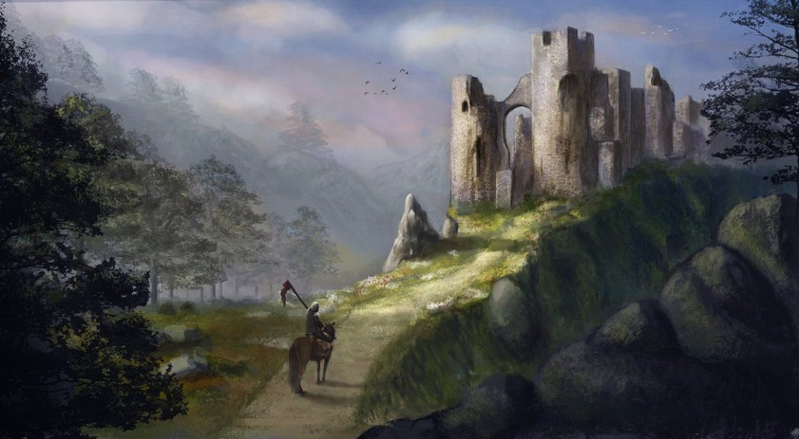

The core rule of the Dreamcatcher is that you first describe the actions of what you want your character to do. The GM will then determine if the action can simply take place, or if a test might be needed to determine success. A test use one of your character’s abilities and the dice to determine the final result of a proposed action.

As Dreamcatcher works on an approach based system, it is useful to think of your character's actions based on how they would approach the problem. For example, if your character is presented with a locked door, they may choose to use brute strength and Forcefully ram the door, they may be more subtle and Deftly trip the lock, or use their mental prowess and Intelligently find a flaw in the doors mechanism that allows it to be opened. Any of these approaches could feasibly overcome the obstacle, but the approach used by the character can determine the test used, and therefore change the chance of success. For more information on these, see the Ability Score section later.

## Tests

A test determines if your character’s raw talent and training are enough to overcome the obstacle presented to them. In many instances the GM will determine that a test is not needed, and that you will simply succeed. For example, if you are walking across a wide bridge in dry, calm conditions. However, if the GM determines that an action has a risk of failure with a significant consequence, he may call for a test. In contrast to the above example, a Deftness test would be called for if the bridge were a narrow rope bridge, swinging in the lashing wind and rain of a storm. Here the dice can determine the outcome of your action.

If a test is required, your GM will ask for a test using an ability of his choice. This should be the ability that best applies to the task.

## Performing a Test

To make a test you first need to refer to the ability on your character sheet.

*Roll the Dice:* To make a test, roll 2D6 (rolling two six sided dice together) and add the relevant ability score.

*Announce the Total:* Tell the GM the result of your test. Any roll of 10 or higher is a success, and any result lower than 10 is a failure.

*Using Advantages and Hindrances:* You have an Advantage you can call, or the GM may call a Hindrance to work against you. In these cases you will need to roll 3D6 and take the highest two numbers when calling an advantage, or the lowest two when suffering from a hindrance.

*Failure:* if you fail a test, you not only do not make any progress, but one of your ability scores becomes hampered, or one of your advantages is hampered if you used one (player choice).

Lyre (stringed instrument)*Combined Advantages and Hindrances:* If a situation arises whereby both a hindrance and an advantage are called or apply, they both cancel each other out (i.e. you roll 2D6 and add your ability normally). In this way, advantages can be used to cancel out a temporary hindrance or a hampered ability. However, if the GM calls a hindrance on your character sheet and you accept it for a destiny point you cannot then use an advantage to remove the hindrance penalty.

NB only one advantage and hindrance can apply at a time, therefore they cannot be stacked (i.e. you cannot use two advantages to cancel a hindrance and then gain an advantage).

## Hampered Abilities and Advantages

If an ability has become hampered then you can still use it, but is treated as if it had a hindrance (i.e. roll 3D6 and keep the lowest two), even if you have an advantage you could call to aid in the situation.

Advantages that have become hampered cannot be called at all until they are recovered.

## Degrees of Success

As already stated, roll a 10 or higher is a success, and anything below 10 is a failure. However, there are two more degrees of success or failure that can apply. If a player rolls a double 6 (i.e. both dice roll 6), then you have achieved a critical success and gain a temporary advantage. Conversely, if you roll a double 1, you suffer a critical failure and suffer a temporary hindrance as well as the normal hamper you accrue for failing as explained above. Therefore, the degrees of success for determine the outcome of a test is as follows, from best to worst:

* Critical Success
* Success
* Failure
* Critical Failure

## Destiny Points

Characters start with a pool of 5 destiny points. These can be spent in one of two ways as follows:

* To reroll one die once per test
* To convert hindrances into advantages between stories (see later)

The use of destiny points for development will be discussed later, but the simplest use for them is to allow a player to reroll a single die once per test. The result of this reroll must be taken even if it is worse than the original roll.

There can be some danger in using destiny points in this way, but if the original roll was a failure or a critical failure, it may be worth the risk.

Destiny points are given out by GMs upon players completing a story, but they can also be earned by accepting called hindrances.

If a GM calls one of the characters hindrances to disadvantage an ability test, the player has one of two options. He can either accept the hindrance and earn a destiny point, or spend a destiny point and ignore the hindrance.

GMs cannot force you to face a hindrance, but neither can they be ignored lightly.

## Resolving the Test

GMs and players are encouraged to resolve the test after just one roll. That is accepting that the attempt succeeded or failed. If any player wishes to try to achieve the same goal again, they must do so using another approach, as the one used previously failed.

More advice on framing tests and resolving them is covered in the Game Mastering section later.

## Contests

Contests are essentially tests that are opposed by another character instead of a predetermined or static obstacle. In these cases, success is determined by the relative fortunes of bother characters, supplemented by their abilities and advantages. The character with the highest degree of success then wins.

*When to have a Contest:* Generally, contests arise when either two characters attempt the same task, such as a race or both characters trying to snatch the same weapon from the rack, or if one character attempts an action that is actively opposed by another. An example of this might be trying to push over a barricade, where an enemy behind it pushes back to support it.

*Resolving a Contest:* the resolution is exactly the same as a normal test, in this case with both characters rolling, adding an ability and using any advantages or hindrances that apply. The character with the highest degree of success wins the contest, potentially either accomplishing a task, or preventing a task being completed as is appropriate.

Negative consequences for failures (i.e. any hindrances) apply as normal during a contest and can effect both participants.

In the case of a tie, then no progress is made one way or the other. In some situations this may benefit one character, as in above if they are holding up a barricade, but otherwise both characters remain in contest over the action for the next round, unless one chooses to concede by performing another action. If a tie would not makes sense in a contest, then a player character will win the contest over an NPC, or in the case of two player character’s contesting, then whichever is considered the aggressor will win. Where there are two PCs and no clear aggressor, then the result is a tie with a temporary advantage for both to be used later in the scene.

With respect to critical success and failures in ties, the following rules apply. If both participants gain a critical success in an opposed contest, then they both gain a temporary advantage to use during the scene, but with the result following the pattern above (i.e. PC over NPC, aggressor over defender etc.).

If both participants roll critical failures in an opposed contest, then they both gain a temporary hindrance that can be called in the scene, but the player character will still win the contest over an NPC, or in the case of two player character’s contesting, then whichever is considered the defender will win. Where there are two PCs and no clear defender, then the result is a tie with a temporary hindrance for both that could be called later in the scene.

## Resolving the Contest

Similar to resolving a simple test, a contest should ideally end once there is a clear winner and/or loser. Rematches are always possible, but players and GMs should be wary of repeating contests to get some desired end.

More advice on framing contests and resolving them is covered in the Game Mastering section later.

However, one contest that is likely to continue beyond just the one roll is combat.

## Combat

If the goal of a test is to overpower an opponent or otherwise defeat them, then this should be resolved as a contest in the way outlined above but with the additional rule below.

Any hindrances suffered due to a test failure are suffered as normal. In addition, the winner of a combat contest, can chose to impose another hindrance on their opponent. The opponent’s player choses if this hindrance applies to an ability or an advantage that could apply to the combat.

Note that an advantage hampered in this way does not have to have been called by the opponent during the current round of the contest, but should be applicable to the action of the scene.

The GM is the final arbiter on which advantages can be used to soak damage in this way, but common sense should prevail. For example, if two soldiers were fighting on a battlement and one lost a combat test, he could chose to have his “Good with a shield” advantage to be hampered even though he used his “Good with a sword” advantage during the fight.

What he could not do, is chose his “Good at swimming” advantage to be hampered unless he gives a good reason for why this should be so (e.g. if he explains that he has taken a leg injury which means he now cannot swim very well). GMs are encouraged to reward creativity, but only within the scope of the setting.

After each test, each participant can chose to continue the test or concede and allow the other to win. If no one concedes, then the contest continues until one participant has been taken out of the scene (see later).

## Multiple participants and Aiding

If there are multiple participants in a test, usually more than one PC trying to achieve the same aim, then one character should be identified as the lead character, and the characters will roll to augment the leads roll.

To aid another in a test, the augmenting characters must describe what they are doing, and how this will aid the leads action. Ideally, this should use an different approach or advantage to that being used by the lead character, but GMs are encourage to use their discretion as to whether the proposed action is in keeping with the game.

In a test, the aiding characters roll as in a normal test (aiming for a 10 or better), and take any negative consequences for a failed roll to aid. If they succeed the lead character’s final degree of success is increased by one level per successful aid (e.g. critical fail becomes a fail, a fail becomes a success etc.).

The final degree of success cannot go above a critical success using this method.

A critical failure not only hampers the aiding character, but creates a hindrance for the lead character. Sometimes a well-meaning helper can make things worse.

If an aiding character rolls a critical success, they not only aid the lead character but can give them a temporary advantage they can chose to use instead of their normal advantage. Alternatively, the critical success can be used to negate a hindrance from a critical failure to aid (essentially, critical successes and failures cancel each other out during aid attempts).

Aiding in a contest works in the same way but with one significant difference. In a normal test, the lead character’s success cannot go higher than a critical success and any aids that would push it up beyond this are essentially wasted.

In a contest (including ones involving combat) each increase above a critical success can be used to reduce your opponent’s success level down by one.

Again, using this method and opponent can only have their success reduced down as far as a critical failure, but surely that’s bad enough.

For more advice on handing multiple participants in contests, see the Game Mastering section later.

## Narrative Override

Most game systems suggest that as the GM, you have the final say on any ambiguities or rules disputes. The spirit of Dreamcatcher is that you should take this much further. As the GM, you shouldn’t let the rules get in the way of your players having a good time. As such, we introduce here the concept of Narrative Override. As the name might suggest to you, this means that you can override the rules of the game, if it is in the interest of making the story a good one.

An example might be that a character doesn’t have an advantage to use a sword. In the heat of a battle with his childhood enemy, he grabs a longsword and uses it to defend his helpless friends from his nemesis. Normally the character would not be proficient with the weapon and would make a simple 2D6 roll. However, the GM decides that due to the critical story aspects of the event, the character pulls up on some unknown inners strength to wield the weapon, and fight his foe with a temporary advantage in the battle.

# Chapter 2: Ability Scores

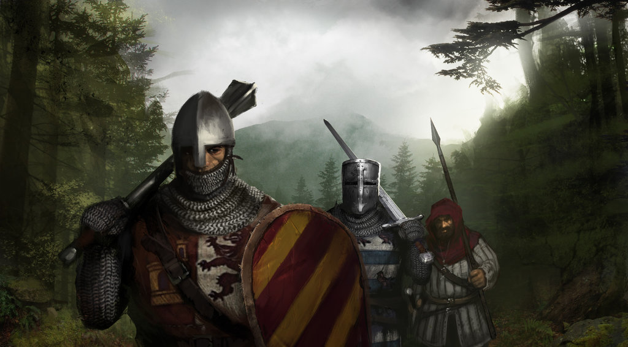

All characters have five abilities: Forceful, Deft, Resilient, Intelligent and Perceptive. These represent the various approaches that your character can take in resolving obstacles or completing actions within Dreamcatcher. A character also has a score attached to each ability. Your ability score broadly defines your natural talent and skill in each of the five approaches. The higher your score, the better your character is with that approach. Typically, all non-player characters and creatures also have values in the five ability scores.

A score of 2 is considered average for a human adult, with a 5 being the highest achievable for a normal person. Adventurers may have scores as high as 6 and monsters and other powerful beings may be even higher still.

Each ability listed is followed by an example of what kind of test that a player would be expected to use that ability for, and an example of the kind of hindrances they may suffer if they fail a test.

## Forceful

This measures your ability to exert physical force using your raw muscle power. Forcefulness is used to perform feats when climbing, swimming, jumping, fighting, and any other situation that would rely on brute force.

### Tests

A Forcefulness test may be called for whenever a feat of force is required to overcome a challenge. Examples include opening a jammed door, pushing over an opponent, arm wrestling another person and so on. Similarly, a Forcefulness test may be needed to resist an effect, such as a severe gust of wind, to hold on to a cliff face for a prolonged period of time, or any other effect the GM feels would require Forcefulness to resist.

## Deft

This is a measure of how, nimble, agile and quick your character is. Deft is used to perform feats where speed, dexterity and balance are needed as well as to avoid blows in combat.

### Tests

A Deftness test may be required whenever your speed, agility or nimbleness is the major factor in overcoming a challenge. Examples include determining turn order in combat, tumbling past enemies, and walking across a narrow ledge to name but a few. A Deftness test may also be used to avoid some kind of danger, such as diving for cover from an explosion or dragon's breath, and avoiding traps, as well as resisting effects than may keep you off balance, e.g. Staying upright on a deck of a ship during a storm.

## Resilient

Resilience is a measure of the physical endurance of a character. It is used to not only determine how tough your character is by adding to hit points, but it can also be used to resist physical effects such as poisoning and disease. Being highly Resilient does not necessarily mean the character is large or robust looking, but it may certainly suggest they could be.

### Tests

A Resilience test may be required any time a character's endurance or physical resistance would be indicated in a test. Examples include running or swimming for a prolonged period of time, or holding your breath under water. As suggested above, a test may also be called for to resist a poison or disease, as well as any supernatural effects that attack the body or health of a character.

## Intelligent

The Intelligence ability measures a characters intellect, memory, learning, recall, quick wits and anything else the GM determines that the Human brain has dominance over. Intelligence is used where brain power or memory would be the deciding factor in a test.

### Tests

The GM may call for an Intelligence test to determine if you know an obscure fact, or recall a piece of important information, and may even allow a test to give clues to solving riddles. The Intelligence ability can also be used to resist effects such as mental domination, trickery, or some spells.

## Perceptive

Perceptiveness measures how observant and aware of their surroundings a character is. It is used whenever a character may be able to notice something, or pick up on minor details that may be useful to them. This ability covers the physical senses such as sight, hearing, taste and touch.

### Tests

A Perceptiveness test may be called for to spot a hidden trap, hear voices behind a door, or notice bandits waiting in ambush behind dense foliage. Perceptiveness is unlikely to be used to resist any effect, but is more likely to be an opposed roll against an opponent’s attempt to hide or deceive you

# Chapter 3: Characters

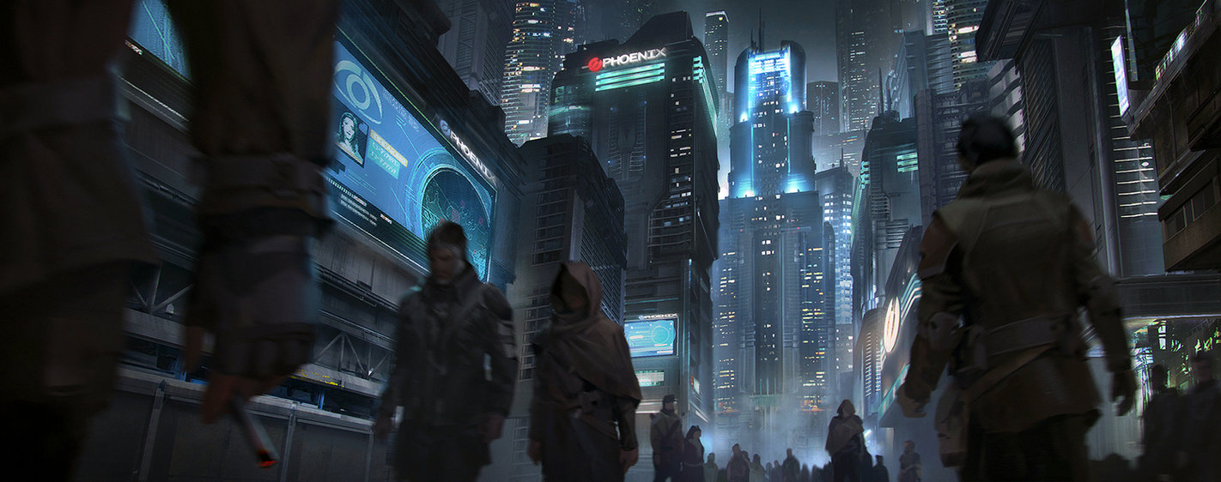

In order to play a Dreamcatcher game, you will need to create a character. This will represent the person you will play in the game. The information about your character will be recorded on a character sheet. In some instances the GM may have characters prepared for you in advance, but usually you will create your own.

Dreamcatcher aims to make character creation as quick as possible, but it still involves a few steps where you will need to make important decisions about your character.

The decisions are laid out below in seven steps that you can follow to create your character.

## Step1: Character Premise

It is always best to start with you initial concept before you make any more decisions about the character you want to play. Do you want to play an honourable knight from a noble house, a skulking thief who is only out for themselves, or a wizard of an ancient arcane order?

Whatever your concept, try to summarise it as a single sentence, and write this in the Character Premise line in the Facets section of the character sheet. Don’t worry about the exact wording, this can always be tweaked as the character develops, but the premise of your character should inform you in the next steps in creating your character.

## Step 2: Assign Ability Scores

At this stage it is now time to think about the mechanics of your character. The outcome of many actions in the game revolves around the numerical values in your character’s abilities. Determining your character’s scores in Dreamcatcher is simply a case of assigning a set of standard scores into each of your character’s abilities: 5, 4, 3, 2, and 1.

You should remember that as 2 is the human average for an ability, that all those above 2 show an above average talent for the approach, and that only one score (the 1), is below average.

“…2 is the human average for an ability…”

It may help when assigning scores to think of it as prioritisation, and consider which ability you feel is most important for your character, assigning that the value of 5, and them working down from there.

When thinking about where to assign each score, it is also worth thinking back to your character premise. Would a knight have a high deft ability, or would they prioritise forcefulness over agility? Would they need to be more resilient than perceptive?

You will need to answer these questions yourself, as the character belongs to you, and it is therefore up to you as to how you play them. If you are the kind of player than wants to maximise your character’s abilities, then it may also be worth looking at the character paths and equipment sections later in the book, to ensure your character has access to the actions and weapons you want.

## Step 3: Create three Advantages

Now you have chosen your five ability scores, you can focus on the three things that make your character special. These should be the things that make you stand out from the crowd, and ideally be in line with your character’s premise.

All advantages should start with the description “Good with/at…” Continuing the example of the Knight above, the player may choose the following advantages:

* Good with a sword
* Good at riding a warhorse
* Good at Jousting

These are appropriate and in line with the character concept.

There are no rigid guidelines on writing advantages, but they should be specific but not too restrictive as to make them hard to ever call during a test.

For example, the Knights sword advantage above is appropriate, but the advantage “Good at fighting” may be too broad (Fighting how, or with what?). Conversely, “Good at fighting with my personal family longsword” is probably too narrow, as you wouldn’t be able to use it with any other sword.

This does not mean you cannot have broader or narrower advantages, but they will affect how useful or powerful characters are in the game.

When considering advantages, it’s worth discussing with the GM as to how specific or board he wishes to be with these before you pick them. This will save on any disappointment.

## Step 4: Create a Relationship

A relationship is essentially an advantage that allows you to make use of a social relationship with another character in the game. These advantages can only be used in situations where the named character would be able to come to your aid, and in some way could help you out in the test or contest.

The relationship should be recorded as, “Has a good relationship with…”, for example:

* Has a good relationship with the Duke of Lancaster

In the case of the above, in any situation where the player can justify either the Duke’s reputation or direct aid to be of assistance, he can call the advantage to help him in the test.

As well as individuals, players can also suggest a group to have relationships with. These may potentially a wider field of expertise than an individual, but they tend to have less social and political impact depending on their nature.

The use of other player characters as your relationships is discouraged as they should instead work with you during the game. Also, powerful relationships (e.g. the King etc.) should not be given or taken lightly.

The GM is the final arbiter on which relationships are appropriate to take during the game.

## Step 5: Create a special Possession

Gear and equipment is handled very abstractly in Dreamcatcher. You are assumed to have access to any equipment that fits with your character premise, at the GMs discretion, but these items will not provide you with any mechanical bonus, they are simply aids to roleplaying.

Exceptions to this are special possessions that are named on your character sheet. These are items with which have a powerful impact, reputation, you have extra special affinity with, or anything else that makes them stand out from the norm.

Unlike advantages above, possessions by their nature should have very specific descriptions. Carrying on our previous example, a normal longsword would give the Knight no advantage, but an “Ancestral longsword balanced perfectly for my hand” would.

Unlike the other advantages, possessions like this can only be given out by the GM either as gifts from other characters, or as rewards for mission, quests etc. Again, these possessions are at the GMs discretion.

## Step 6: Create four Hindrances

As an opposition to your advantages you should now create four hindrances for your character (one for each advantage, excluding your special possession). The important thing to consider here is that these are not your character’s flaws so much as things they are not good at, but which they want to be better at.

Therefore, consider things that your character wants to be better at, but can’t do very well at the moment. The reason why this is important will be made clear when we look at character development later.

At the GMs discretion, one of your starting hindrances can be a poor relationship (see above), but it may be more appropriate to allow these to emerge through roleplaying and character development.

All hindrances should start with the description “Not good with/at…” Using the example of the Knight above, the player may choose the following hindrances:

* Not good at swimming
* Not good at heraldry
* Not good at talking to serfs
* Not good with a crossbow

These are appropriate and in line with the character concept.

The GM can call these hindrances whenever he feels they are appropriate and players are free to suggest calling them at any time too. Calling a hindrance is a good thing, as it can earn you a destiny point and will allow you to improve your character later.

## Step 7: Personal Touches

Now you have assigned your characters abilities, relationships, hindrances, and equipment you are almost finished. The character sheet has spaces to record the details that will make the character unique for you and enhance your roleplaying experience, if you have not already done so, now is a good time to look more at these.

### Character Description

This section at the top of the front page of the character sheet is where you record all the details of what your character looks like, and a section to describe how they appear to others, including any personality traits you wish them to have.

**Pick a name.** You should come up with a suitable name for your character. There are no hard a fast rules for this, but consider something you feel fits with your concept.

**Description.** A final section is left for free text description. Here you can describe any distinctive characteristics such as tattoos, scars and the like. You can also describe clothing, general appearance and personality traits in this section.

## Step 8: Play your introduction

Now you have completed these steps you are ready to play your introduction adventure. This adventure is designed to give you a chance to get to know the game, your fellow players, and form your adventuring party.

The GM can also allow you at this time to makes some changes to your character’s advantages and hindrances based on your introduction. Ideally, this should represent the dramatic change in their life caused by their experience, but it can also help if you didn’t quite get your abilities right.

The aim of Dreamcatcher games is to work collaboratively with your other party members to ensure you complete goals, quests, missions and the like. This does not mean you have to always agree with each other, but you should work with the GM to ensure that the party is compatible enough to work together without stepping on each other’s toes.

## Step 9: Character Development

Character development is done thought a combination of two methods. The facing of your hindrances, and the expenditure of destiny points.

As explained in chapter 1, you can earn destiny points by accepting hindrances during a test, but further to this, every time you accept a hindrance and succeed in the test, you can place a check next to the hindrance.

Once a hindrance has been checked, you can spend two destiny points to turn this hindrance into an advantage. To do this, simply remove it from the hindrance section of your sheet, and change the “not good” section of the text to “good”.

*For example, Valar the Thief, played by Joe, was “Not good at shadowing people” but during an adventure he had accepted the hindrance while he made a Deft test to follow a wealthy merchant back to his house.*

*Despite the hindrance he still succeeded, and placed a check mark next to this hindrance. After the end of the adventure, Joe spent 2 of his remaining destiny points to change this hindrance to an advantage. Now Valar has the advantage “Good at shadowing people”.*

As well as gaining the new advantage, the player must then select TWO new hindrances to replace it. This way the number of hindrances should always match your advantages.

These new hindrances should be in keeping with your character’s premise or experiences during the adventure, and if possible should reflect tests he failed during the last story. Similarly, if he has suffered any temporary hindrances, these can be made permanent if it’s appropriate.

The GM is the final arbiter in what can and can’t be taken as these hindrances, but the decision should be made collaboratively and with some degree of flexibility.

*In our example, Joe has made Valar good at shadowing, but during the adventure he failed in his attempt to bluff his way past some guards. Also, Valar had a run in with the local thieves guild who are none too pleased about an unregistered thief running around. Therefore he adds “Not good at bluffing” and “Has a poor relationship with the Thieves Guild” to his hindrances.*

# Chapter 4: Games Mastering

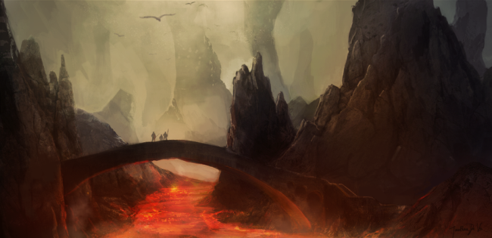

This section of the rules is intended to be a helpful resource for GMs when running Dreamcatcher games.

## Time

Time in Dreamcatcher is treated more fluidly than many tactical roleplaying games. Instead of rigid turn or rounds, player’s actions take place in scenes that make up part of a chapter or larger story.

Players have the majority of control over scenes, but the GM should direct them and facilitate the end of scenes to move on to the next scene or the conclusion of the chapter or story.

### Scene

A scene is the shortest measurement of time in Dreamcatcher, but can be anything from a few seconds to several days depending on the situation. A scene is like a scene or chapter of a book. It usually takes place in the same location or area and involves a short interaction with the surroundings or people.

A scene may or may not involve a test or contest, but at the very least the players will have to describe what their characters are doing and what they try to achieve in a scene.

Traditionally, a scene ends when the characters or the GM feels it’s time to move on to a new one. It is likely to be quite clear in practice as to when a scene begins or ends.

An example of a scene may be the characters going to the King’s audience chamber to petition him for aid in the war against the northern barbarians, or a dramatic car chase through the streets of Paris.

### Act

An act is an optional measure of time. It is simply a collection of scenes that make up a subsection of a story. They can be useful to divide a story into manageable sections, but they are by no means mandatory.

For example, the first act of a story might be scenes in which the characters gather clues on serious of mysterious crimes and rituals that are taking place around the city. The second act could be a series or run ins with the evil cultists who are trying to hamper their investigations. The final act could then be the scenes where the characters sneak in to the evil temple and finally face the cult leader.

### Story

A story is a collection of scenes that ultimately lead to some final or larger resolution. For example, the characters could be investigating mysterious murders in a town, and the story is resolved when either the murder is caught, or he escapes the player’s clutches. In the example of acts above, all three acts would make the story.

### Session

A session does not relate to game time, but is the real life time period in which players get together with the GM to play through scenes or even whole stories. Some actions may only occur between sessions.

## Distance and Movement

Distance in Dreamcatcher is as abstract or as accurate as you want it to be. It is less important during scenes as to exactly how far people can move or shoot, as it is that players are able to describe what they are trying to do. If the GM feels that the goal is not achievable based on the physics of the world then then simply need to say so, if it is simply difficult they can chose to apply a hindrance to the roll if they feel it is appropriate.

Larger distances should be handled in whatever way works best with the group. If you want to use accurate maps and realistic measures of movement then feel free, but if you agree to wing it and guestimate travel times then just do that.

As with most rules in Dreamcatcher, the GM is the final arbiter in what is or isn’t allowed.

## Perception

The world is subject to many things that can affect how well your characters perceive it. Darkness, mist or smoke to name but a few. GMs can use these just from atmospheric effect, or they can be used to create a hindrance for your characters. In some settings, you may be able to obtain equipment or have species traits that can overcome these hindrances.

All such advantages are to be used at the GMs discretion.

## Hampering, Injury and Death

Any time a character fails a test or is bested in combat, they must hamper either an advantage or an ability. In Dreamcatcher, such hampering constitutes the reduced ability of the character to continue in the story. A character can continue with the story so long as they have at least one ability which isn’t hampered, but if they have all of their abilities hampered, the character is taken out of the scene, or even longer.

### Hampered Abilities

Hampered abilities usually, but not always, represent some kind of physical or psychological trauma. Essentially, the character has becomes injured in such a way that they cannot use the ability as well as before.

As stated previously, hampered abilities can still be used to complete tests, but they do so as if they were being called with a hindrance (i.e. roll 3D6 and use the lowest two dice).

### Hampered Advantages

If an advantage becomes hampered, usually due to being called during a test which failed and used to ‘soak’ the failure, then it cannot be used again until it is recovered (see later).

This hampering can be anything that makes sense as part of the narrative and can include physical injury, social exclusion, fatigue, illness etc. It is optional for characters and GMs as to if they record what the hampering actually is.

### Hampered Relationships

If a relationship becomes hampered as part of test or contest then it is not useable until it is recovered and could mean either damage to the relationship, injury of the individual/group or a restriction on those persons to aid the character.

Examples can include a friend being injured protecting you, a snitch being kidnapped by a criminal organisation, or a patron being displeased with the demands you have made on them.

Such hampering should reflect the likely effect on the other party if the test should fail. Recover will involve the situation changing either by time or direct player action.

### Hampered Possessions

If a possession is hampered, it has been rendered useless in some way, either it has become damaged, lost, powered down or otherwise removed from the immediate action.

Again, it cannot be used again until it has been recovered in some way.

### Being Taken Out

If a character has no choice but to hamper the last of their abilities as part of a test or contest, then they are taken out. A character that is taken out is removed from the scene in a way chosen by the GM and cannot return to the story until they are able to recover at least one of their abilities.

Being removed from the game in this way should not normally result in character death (see below), but is not ideal for the player as they have no say in what actually happens to their character.

### Co*nceding*

If during a contest, usually combat, a player is concerned their character will be taken out, they can instead chose to concede the contest. This results in them losing the contest and being taken out.

However, the character takes no further negative effects (i.e. no other abilities can be hampered), and the player decides how the character is removed from the current scene. They are then free to return to the next scene as they will have unhampered abilities remaining.

### Advantage Death and Destruction

Any permanent loss of a person or item cannot be done without the consent of the player and should only occur from a critical failure during a dramatic scene. As removing such advantages can reduce the strength of a character, the GM should work with the player to create a replacement very rapidly (i.e. during the same or subsequent story).

### Character Death

As stated above, being taken out shouldn’t routinely result in the death of a character. However, a player may choose to have a character die if they are taken out during a test or contest. This choice must always be the players, and they then choose exactly how the character dies (overriding the rule above).

The death does not have to be literal (although it’s more dramatic if it is), as they character could suffer a metaphorical death. This may be more appropriate, especially in situations where they have lost a social or intellectual conflict.

The upside to character death is that the player can create a new character with all their advantages and abilities unhampered. Albeit at the loss of their beloved character.

The new character can be at the same competence level as the old one (i.e. the same number of advantages), or have only the starting advantages at the GMs discretion, but this must be explained to the player before they agree to the death.

## Healing and Recovery

There are two ways in which characters can recover from their abilities and advantages being hampered.

### Recovery between stories

At the end of each story, each player can chose one ability or advantage to automatically unhamper. For all other abilities and advantages that are hampered, the player rolls 2D6 and on an 8 or higher it recovers and becomes unhampered.

This recovery represents rest, recuperation, medical treatment, psychological treatment, social interaction and any other activity that can fix the damage done. This recover takes time and so does not occur during a story.

### Recovery during a story

At the GMs discretion, a player with a relevant advantage (e.g. medical skill, psychoanalysis, magic etc.) can make a check to help recover one advantage or ability per player either during or immediately after a scene.

To do this, the healing player must make a test with the relevant advantage. On a success they recover the ability or advantage, and on a critical success they can recover two. A failure results in the loss of the healing advantage as normal, and a critical failure results in the loss of this advantage and further hampering of the character (e.g. another ability or advantage becomes hampered as well).

Please note, that no matter which advantages are used, only one test can be made per character per scene.

## Managing Scenes

This section gives advice on how to open, manage and close scenes. When a scene closes it should ideal flow into the next scene as naturally as possible.

### The first scene

There is no hard and fast rule about who should open a scene, but often the first scene will be proposed by the GM in order to start the story. If, however, a player proposes a scene to start the story, the GM should consider it if it’s in keeping with the story so far

Taking tips from story writing, the best way to open a story is in media res, that is, in the middle of some action. The characters and thus the players should be thrown straight into some kind of action. Whether it be an unexpected combat, a summons in front of the King or some other similarly dramatic situation is not important, just so long as it’s engaging for the players.

I would suggest not opening with characters getting out of bed, going shopping, or some other mundane task, unless you plan to throw some unexpected action at them pretty quick. Get the action going as soon as you can.

### Managing the flow of the scene

In most cases the flow of the scene should take care of itself. The players should lead on proposing what their characters do, and GM translates this into descriptions of what happens, tests, or contests as needed.

Occasionally a scene may start to stall. That is, the players may start to struggle with ideas of what to do next, or where they should go. In all likelihood, this is a signal that the scene is coming to an end, and the GM ought to move towards closing the scene (see below).

If there is merit in the scene continuing, then you as the GM can consider giving some hints to nudge the players in the right direction. Beware overusing this tactic however, as you can end up directing all the action and start railroading your players to where you want them to go rather than by what they want to do.

Subtlety is better here, and maybe just have NPCs hint at information they may have, rather than suggested things out of character. Remember, NPCs have motives too. Use them to your advantage here.

### Closing the scene

Eventually any scene will have to end. It’s more than likely that your players will start to do this for you, suggesting that they go somewhere else, or move on to questioning another character.

Ideally you should aim for this transition to be led by players as much as possible but, as stated above, sometimes the scene can begin to slow as players lose a sense of what they are doing.

If you feel they have gained all they need from the scene, prompt them to consider where they can go next. Here again, subtlety is best. Rather than stating you can go here, here or here, perhaps ask them to summarise what they have learned, and where they think they need to go next.

In the end, if all else fails, then a GM you always have the option to either suggest a next scene, or throw in some action to move things along.

The action method can sometimes be the best. Depending on your setting, a sudden attack or other dramatic occurrence (perhaps a theft or an arrest) can get things moving along nicely. Never be afraid to shake things up a bit if the plot begins to stall.

### Proposing the next scene

Leading on from the above, at least one of the players should propose the next scene. In these cases they should describe where they are going or what they are doing to start the new scene. As GM you would then take the prompt to describe how this scene begins, and let the players begin the interaction all over again.

If you have introduced some action to start a new scene, you will have proposed the new scene yourself, but again allow the players to lead the action once it has commenced.

## Managing Test

A test will occurring during a scene, if and when at least one player proposes an action that you as the GM feel has a risk of going wrong in a dramatically appropriate way.

### Is a test required?

This is an important question that should always be asked, and equally applies to contests. Really think about what making the player roll for the result will add to the scene and their enjoyment of the game.

Many a game has been spoiled by characters having to roll to go up and down a ladder in a well light house in perfect conditions. Other than a comedy factor if it goes wrong (which may be appropriate depending on the kind of game you are playing), what does that add?

Now, climbing up a ladder made slippery but torrential rain, as you attempt to flee a band of thugs bent on your destruction… that makes for some drama. Here, a test would be perfect.

As the GM it is your job to keep the game flowing, so remember that tests and contests can break up the flow of a story if used too often, but can really add to the tension when used at the right time.

If a test feels appropriate, then next step is to determine what is occurring, and what the player wants to achieve. In other words, they need to frame the test.

### Framing the test

### Resolving the test

### Useful failures

## Managing Contests

Contests should be called in a similar fashion to tests (i.e. only when dramatically appropriate), but where the outcome is based on an important interaction between more than one character.

## NPCs

### Mooks

Mooks are disposable NPCs. These are the kind of uncredited characters you see in movies that are taken out by the heroes in a strike or two. When assigning statistics to Mooks, they are assumed to have a score of 1 in every ability, and no advantages to call.

Regardless of their abilities, Mooks only ever have one hindrance box. Once this has been used, the Mook is taken out of the scene.

Due to the nature of Mooks, the GM can choose to either handle them individually, or use them collectively as a mob. If they are collated as a mob, then their hindrances boxes are combined.

Mundane animals such as rats, dogs and possibly wolves can be treated as Mooks for the purposes of combat.

### Named Characters

These have two advantages and two hindrance boxes. Essentially they are foundation characters but with reduced statistics.

Ability scores: 1, 1, 2, 3 and a 3

### Significant Characters

These characters are approaching the level of the PCs, they will often three or four advantages but should always be less influential than the PCs. This may be either due to their statistics, advantages or both.

Ability scores: 1, 2, 2, 3 and a 4

### Major Characters

As the name suggests, these characters occupy a major role in the story that is being told. Major NPC characters should be created and advanced in the same way as normal PCs. They should have player level statistics (i.e. a 1, 2, 3, 4, and a 5 in their abilities) and advantages that are comparable to, or perhaps even slightly exceed those of the main party.

Major characters can be either a significant mentor, superior or other ally to the party, or they could be the main villain or villains that the party are trying to overcome.

### Monster

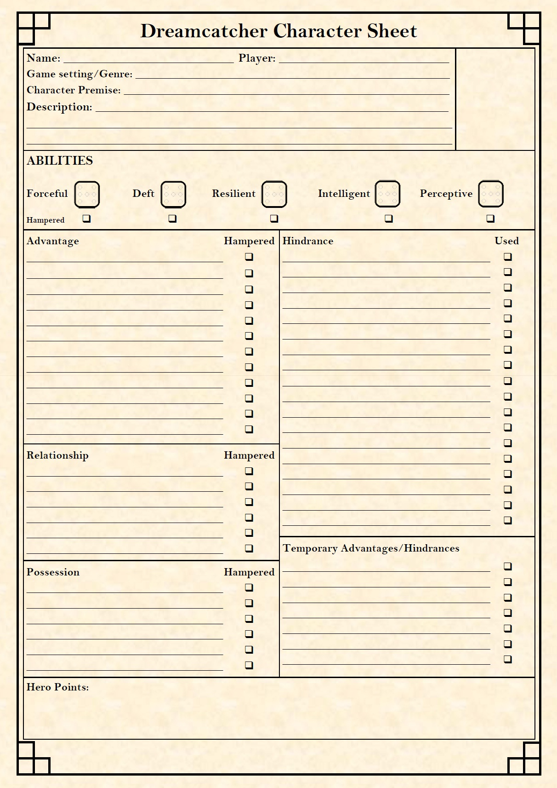

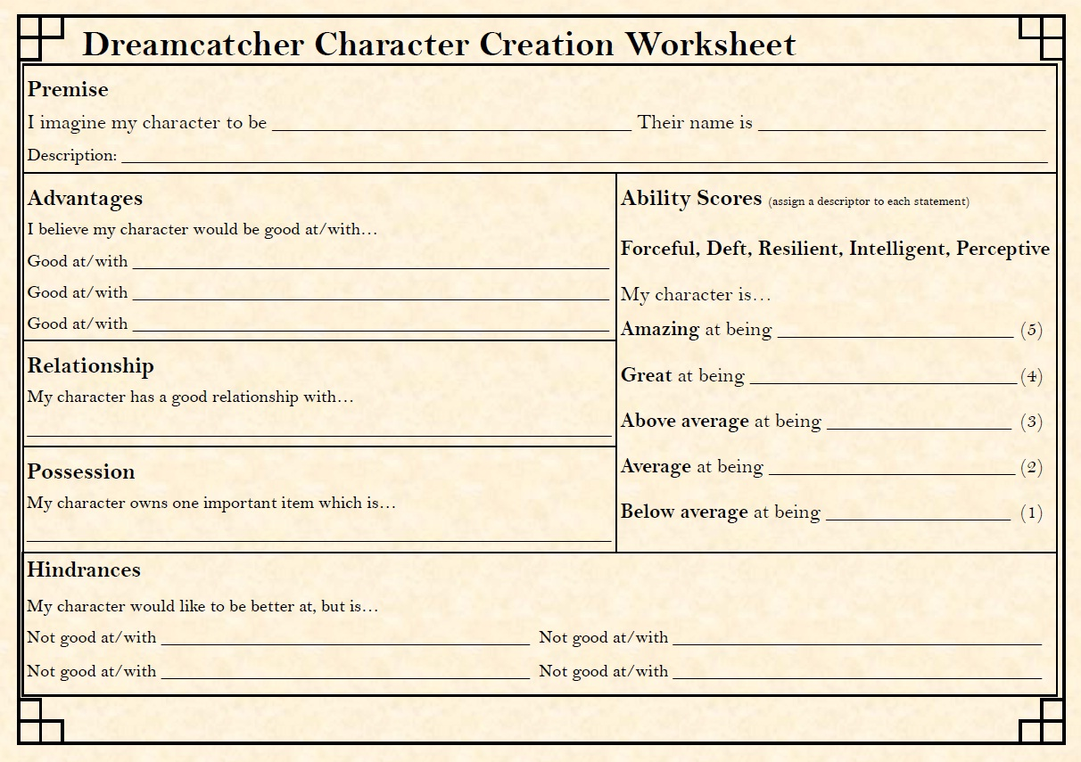

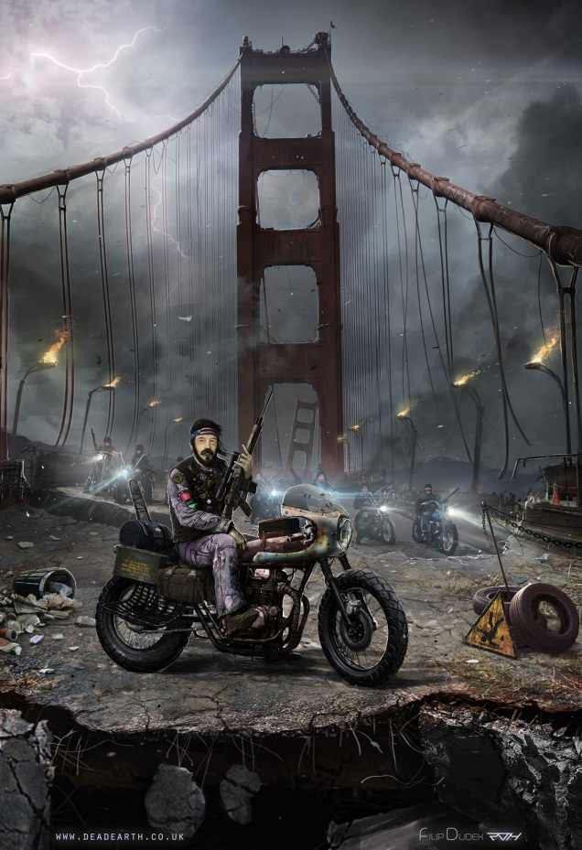

Back Blurb